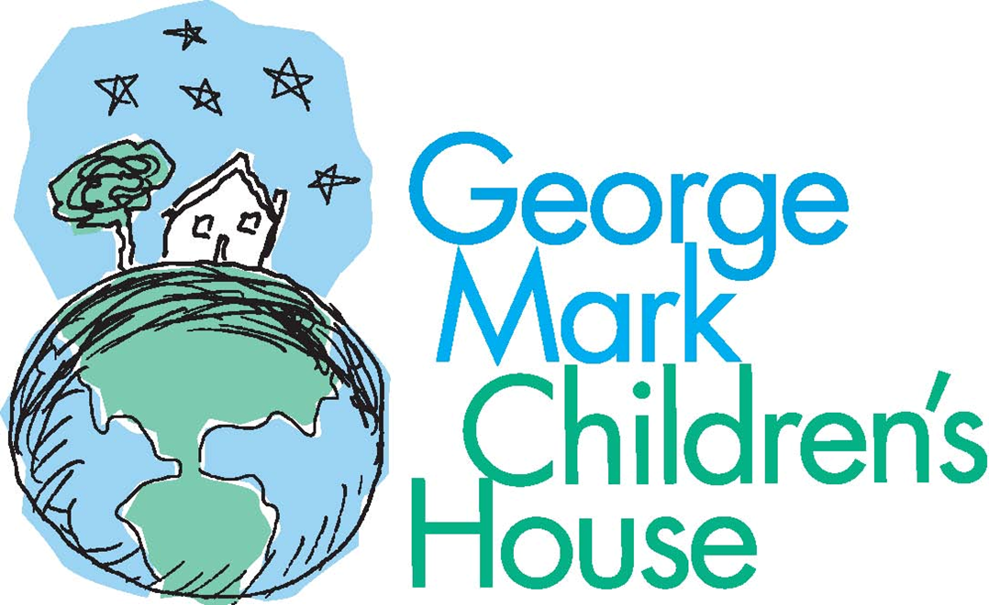

POSITION: Senior Advancement Officer
DEPARTMENT: Advancement
REPORTS TO: Director of Advancement

MISSION STATEMENT
“The Mission of George Mark Children’s House is to provide an important addition to the continuum of care for children with life-limiting illnesses; enhancing the quality of life for the entire family by offering medical, emotional, spiritual, and respite support in a home-like setting that is full of life and activity regardless of ethnicity, gender identity, religion, sexual orientation, national origin, or socioeconomic status.”

POSITION SUMMARY
This is a salaried, exempt position, which may include some weekend and evening hours as needed. Reports to the Director of Advancement (DOA) and works closely with other members of the Advancement Team, the CEO, Board of Directors, and other GMCH staff.

This position is a critical member of the GMCH Advancement team and will be responsible for working with individual donors interested in supporting the mission. The position will work in collaboration with the DOA and CEO to develop fundraising and solicitation strategies that result in increasing levels of support for the organization. The ideal candidate possesses a proven track record in fundraising including major giving, corporate and community relations, events, and building a network of donors. Serves as an articulate, enthusiastic, and visible spokesperson for the organization.

ESSENTIAL FUNCTIONS OF THE JOB
- Cultivate and grow individual donor portfolio (60%)
- Portfolio target of 100 Households; includes donors giving $1,000+ in past two years and/or lifetime giving of $25,000+
- Initial territory between San Francisco and South Bay
- Donors out of the state of California

- Lead advancement funnel audit, process mapping, and systems review resulting in an engagement strategy and Advancement scorecard (30%)
- Meet with the Advancement team to learn current processes, tracking systems, and datasets.
- Meet with Advancement, Clinical, and Psychosocial teams to understand our events and stakeholder engagement touchpoints and communications. Events and engagements include but are not limited to: GMCH fundraising and cultivation events, community fundraising events, medical community events, corporate volunteer events, donor meetings, and GMCH family events.
- Identify gaps and opportunities to build outreach, communications tracking, and engagement strategy for key stakeholders and touchpoints.
- +
- In association with the Database Administrator, build a data tracking system to audit the process and provide insights and recommendations on ways to continue to evolve our process.
- Bring and leverage external expertise and data points to help evolve our metrics and help identify areas to prioritize/deprioritize.
- Recommend any key systems upgrades/evolutions needed to best serve our needs and goals.

- Support in Community events and donor recognition (10%)
- Periodically attend community events.
- Manage the organization’s donor recognition program.

POSITION REQUIREMENTS
General Requirements
- Works comfortably in a sub-acute health care setting serving children who are seriously ill and/or dying, and their families.
- Perform job duties in an ethical and culturally sensitive manner without regard to any protected category as defined by federal, state, or local law.
- Must have personal, reliable transportation, valid and current CA Driver's License, good driving record, and insurance.
- Background check will be required based on job duties.
- Must have personal initiative and work collegially with a team.
- Must have advanced written, verbal, editing, and proofreading skills.

Fundraising Requirements
- Ability to identify and engage new and prospective donors and funding partners.
- Stays current on donor relations and stewardship trends, strategies, and services offered by non-profits.
- Communicate effectively with donors, community stakeholders, patients, patients’ families, staff, volunteers, and contractors.
- Strong knowledge base of major donor programs.
- Provide a high level of professionalism, responsiveness, and customer service to internal and external constituencies.
- Demonstrated ability to establish and maintain effective relationships and interactions with high-level internal and external individuals is essential.
- Demonstrate a high level of initiative, attention to detail, and the ability to follow through on assignments to completion.
- Strong organizational skills, with demonstrated ability to prioritize, coordinate several projects simultaneously and work independently or with a team.
- Daily, show the skills and basic competencies of an advancement professional, including managing multiple, competing, and varied tasks, time management, listening skills, problem-solving, decision making, delegation of duties and successfully managing workflow.
- Excellent client service skills, including in-person and on the phone.

EDUCATION AND EXPERIENCE
- BA or BS degree or equivalent in a related field.
- Minimum of 3-5 years of experience in fundraising with a successful track record of closing gifts.
- Demonstrated success and experience in fundraising, community and public relations, public speaking, and marketing at nonprofit organizations.

PHYSICAL, MENTAL, AND ENVIRONMENTAL REQUIREMENTS
Working conditions in the interior of GMCH are clean, well-lit, and free from extremes of temperature and humidity. Ability to sit, climb, reach, stand and bend, have use of both legs and hands, possess the ability to have a broad range of wrist/arm motion. Ability to grasp/hold objects and tools. Must be able to lift up to 25 lbs. alone and up to 50 lbs. with assistance. Hearing sufficiently to understand conversations, both in person and on the telephone. Reasonable accommodations may be available for some physical demands and mental demands for otherwise qualified individuals who require and request such accommodations.

KEY: “C” for constantly, “F” for frequently, “O” for occasionally, and “N” for not at all.

On the job, the employee must:
PHYSICAL |  |  | MENTAL
(F) Bend | (C) Sit | (C) See | (C) Communicate orally in English
(F) Squat | (F) Stand | (C) Hear | (C) Read/comprehend in English
(N) Crawl | (F) Walk | (O) Smell | (C) Write in English
(O) Climb | (C) Handle Objects |  | (C) Reason and Analyze
(O) Kneel | (F) Push/Pull | (O) Taste | (C) Perform calculations
(F) Reach above shoulder | (C) Reach below the waist |  | (C) Prolonged concentration/intensity
(C) Coordination, including eye-hand and eye-foot | (C) Use of fine finger movements |  | (C) Multi-tasking/Listening

Must carry/lift/push/pull loads of: (O) up to 25 lbs., (O) from 25 to 50 lbs., (N) over 50 lbs.

ENVIRONMENTAL WORKING CONDITIONS
On the job, the employee may encounter or be exposed to:
(O) Chemical/Biological agent or fumes | (N) Confined or cramped spaces
(N) Construction activities | (O) Elevated work locations
(O) Contact with water/liquids | (N) Radioactive materials
(O) Drive motorized equipment | (O) Temperature variations cold/hot/climatic changes
(O) Gas systems | (N) Other
(O) Dust

OTHER
This job description lists the major duties and requirements of the job and is not all-inclusive. Not all duties are necessarily performed by each incumbent. Incumbents may be expected to perform job-related duties other than those contained in this document and may be required to have specific job-related knowledge and skills.

Approved by: ___________________________________ Date: ____________
Employee

Approved by: ___________________________________ Date: ____________
Director of Advancement

